Received 22 August 2024, accepted 1 September 2024, date of publication 6 September 2024, date of current version 30 September 2024.
Digital Object Identifier 10.1109/ACCESS.2024.3455892
A Novel Framework Using Deep Learning
Techniques And Price Prediction in Karnataka

K. MEENAAND B. CHAITRA
Department of Computer Science and Engineering, GITAM School of Technology, GITAM University, Bengaluru 561203, India
Corresponding author: B. Chaitra (cmanjuna@gitam.in)


ABSTRACT Indian agriculture is diverse, employing a significant portion of the country’s population. In southern states of India, Rice and Ragi are the main crops. Ragi cultivation provides economic benefits to farmers in India. Many startup companies are coming up with Ragi based Noodles, Pasta etc. But the price of the Ragi is fluctuating due to various factors such as weather, yield, economy etc. The literature had focused on the price prediction of other crops like corn, Rice, fruits and vegetables etc. This motivated us to work on Ragi as it is a promising crop. Hence, the time series based deep learning models plays a crucial role in predicting the price. In this research paper, various algorithms such as Long Short-Term Memory (LSTM), Gated Recurrent unit (GRU), Vector Auto Regression (VAR) and Convolution Neural Network (1DCNN) are used to predict the price of Ragi. VAR, a time series model is predominantly used for time series applications and LSTM is a deep learning algorithm that has given consistent results in several domains. This influenced us to develop a novel framework VAR-Stacked_LSTM for crop price prediction. The performance of the proposed approach is experimented using Root Mean squared error (RMSE)and Mean Absolute Percentage Error (MAPE) metrics. The proposed framework VAR-Stacked_LSTM yields better performance compared to other models considered for experimental investigation as the RMSE is 116 and 117 in several regions and MAPE is 0.04 around 4%. Further, it is enhanced to predict the monthly price range for Ragi. This unique approach projects the lower and upper range, and it was validated with the actual price. The experimental result proves the efficiency of the proposed framework.
INDEX TERMS Agriculture, Ragi, price range prediction, deep learning, time series models.

I. INTRODUCTION
Agriculture is the prominent occupation in India. Around 159.7 million hectares are used for cultivation. Staple crops like Rice, wheat, Ragi and pulses dominate. Ragi is majorly grown crops in Karnataka.
- IMPORTANCE OF RAGI CROP PRICE PREDICTION
Ragi is also called as finger millet that has several benefits contributing to both human health and Agriculture. From nutritional perspective, Ragi is rich in nutrients, Iron, fiber and calcium. It is gluten free and makes it suitable for those who are gluten sensitive. It has several health benefits that include improved digestion, cholesterol management and blood sugar control. Growing Ragi offers several ecological
The associate editor coordinating the review of this manuscript and
benefits as it is well adapted to diverse climatic conditions. It can also be grown in regions with poor soil fertility. Due to its flexibility, it can aid in preventing soil erosion and improves soil health. It is a dietary supplement for combating malnutrition. It is also a drought resistant crop and henceforth it is a best option for farmers in water scarce regions. Ragi cultivation further provides economic benefits to farmers. It has a short growing cycle hence allows multiple harvests in a year. It has versatility in usage. It is used in food products to animal fodder which eventually enhances its market demand.
- MOTIVATION AND JUSTIFICATION OF PROPOSED
WORK
approving it for publication was Prakasam Periasamy. having small landholdings. The price fluctuations and market
2024 The Authors. This work is licensed under a Creative Commons Attribution-NonCommercial-NoDerivatives 4.0 License.
VOLUME 12, 2024 For more information, see https://creativecommons.org/licenses/by-nc-nd/4.0/ 136103
Farmers are facing several challenges in cultivation such as droughts, floods [2], crop failure etc. as well as many farmers
volatility make income unpredictable. In addition to it, the younger generation does not find this profession lucrative. The experienced farmers do not have adequate knowledge to use technology to enhance productivity. There is a need to use technology and guide the farmers to predict the price of crops. This motivates us to develop a deep learning framework to predict prices of Ragi.
From the available literature, it is observed that the time series model such as Auto Regressive Integrated Moving Average (ARIMA) [21], Seasonal Auto Regressive Integrated Moving Average (SARIMA) and Vector Auto Regressive (VAR) models are predominantly used for price prediction. It is also proven that deep learning models such as LSTM [17], GRU [8], and RNN [21] also performs better with time series data. An attempt is made to combine time series model and deep learning algorithm. The experiment is done to follow the hybrid approach of VAR-Stacked_LSTM. This approach was earlier used for workload calculation [17] and for statistical purposes [4]. Here in our study, we have combined both models for crop price prediction.
This research work considers the input data as Ragi prices of several regions of Karnataka. Many of the researchers used the deep learning models such as VAR, LSTM, 1DCNN [9] and GRU for price prediction. Mean Absolute Percentage Error MAPE [10] is considered for error prediction. There is a need to find the minimum number of years required for the price prediction. This Research gap is addressed by identifying the minimum number of years required for the prediction. The AIC and BIC scores are used to identify better performance of the time series models considered for analysis.
The existing works had focussed only on the actual price prediction and will not predict the range. In this research work, we have also included one additional layer to the model. A Novel approach is introduced for predicting the Range of the crop price prediction in contrast to the existing system. It helps the farmers to identify the appropriate time for cultivation as well as selling the crop.
The VAR-Stacked_LSTM monthly price prediction of the proposed month is taken, and a delta is computed to predict the range. The delta is used for the monthly predicted price to show the upper and lower range. The actual price is then compared to check whether it is falling within the range. The proposed method is a new approach where the price range is calculated and has given extremely better performance compared to existing models used for the experimental investigation.
C. ORGANIZATION OF THE PAPER
The research paper is structured as follows: Section II focuses on the previous related works. Section III includes set up of experimental data, time series models, the proposed novel model and its principle. Section IV presents forecasted results from different models. Finally, Section V concludes the paper.
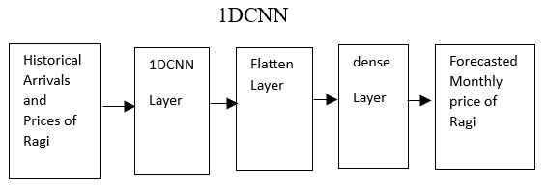
FIGURE 1. 1DCNN model for monthly Ragi Price Prediction.
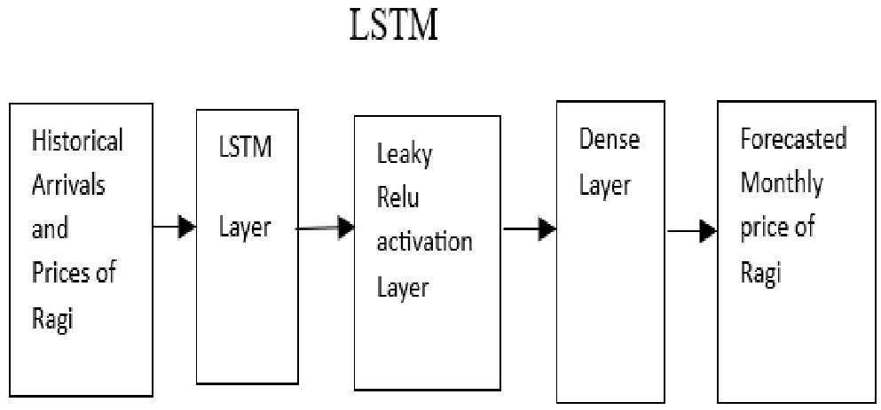
FIGURE 2. LSTM model for monthly Ragi Price Prediction.
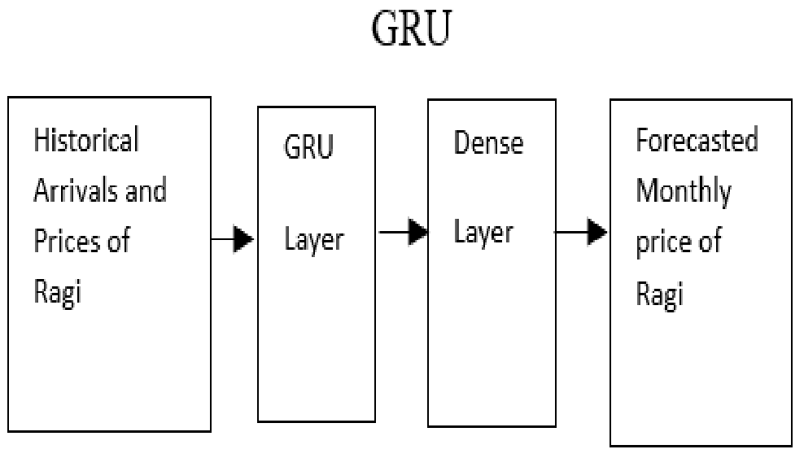
FIGURE 3. GRU model for monthly Ragi price prediction.

II. RELATED WORK
Ouhame and Hadi worked on cloud hosting platforms [17] for allocating hardware resources by predicting future needs of computation. Their work focused on hybrid approach by combining VAR and LSTM model to predict the workload of CPU and memory usage in virtual machines. Their method incorporated two metrics CPU and memory usage. The VAR model identified linear interdependencies and stacked LSTM captured nonlinear trends of VAR model.
Sneha and Bhavana’s study focused on usage of the ARIMA model to predict the price and yield of the sugarcane crop [19]. Their research demonstrated on how the forecast of the yield of sugarcane depend on several factors such as the Rainfall, previous yield in a particular region and the cultivation state. Also, their study had highlighted the use
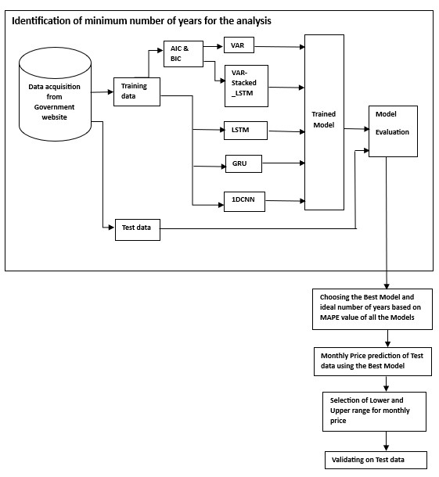
FIGURE 4. Proposed Framework for monthly Ragi price forecasting.
of time series algorithms for forecasting sugarcane prices by considering historical price data.
Dave et al. emphasized the pivotal role of exports in a country’s economy. They stressed the significance of local export forecasts that guide for effective governmental policymaking, predicting local productivity, and planning for international trade activities. They applied machine learning algorithms for the prediction of Indonesia’s exports [5]. They used hybrid models that ingeniously combined the strengths of the time series ARIMA and LSTM models.
Sharma et al. focused on anticipating the prices of vegetables, fruits, and pulses that farmers can expect from their yields [2]. Their method examined past trends by considering various factors such as temperature, pH, humidity, precipitation and market prices for specific set of vegetables, fruits and pulses. They applied Decision Tree and Regression models to predict the yield and price of upcoming years based on the previous year’s data.
Kaur et al. proposed a novel crop yield forecasting framework called YieldPredictNet, which integrates soil and meteorological data [1]. The model was based on LSTM with multi-head self-attention. Their method involved key design considerations such as spatial variations through location, clustering them based on soil and meteorological characteristics, accommodating changes in crop cycle timing, and using weekly granularity for meteorological monitoring.
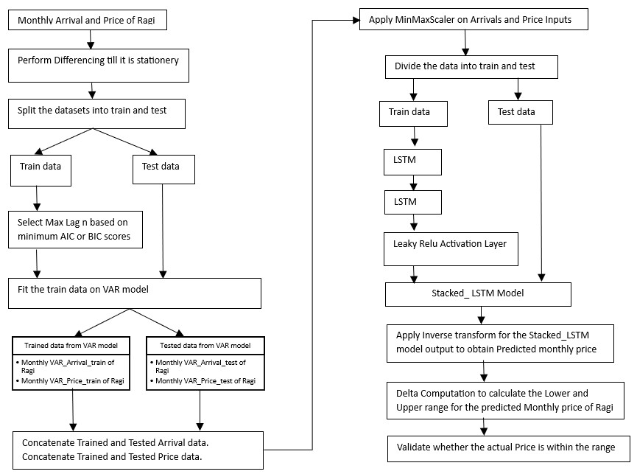
FIGURE 5. Workflow of VAR-Stacked_LSTM model.
They introduced another attribute selection unit to identify significant soil attributes and their corresponding depth levels for improving accuracy for crop yield forecasting systems.
Mohanty et al. presented an innovative framework to aid farmers in anticipating profit or loss through price prediction [10]. The framework had four key components: crop yield prediction, demand prediction, supply determination, crop price prediction. Input parameters included diverse field values, including crop inventory, yield, import data and crop prices. They employed time series-based algorithms such as exponential smoothing and autoregression.
Dharsini and Babu had introduced a novel Minimum Support Price (MSP) method in Agriculture. The research methodology involved several key stages [20]. It began with the collection and preprocessing of images. Later feature extraction techniques and spatial feature extraction were applied to processed images. The deep feature extraction method used CNN algorithm with the processed images.
TABLE 1. Performance evaluation as per RMSE using AIC scores.
This information is further processed through the enhanced Recurrent Neural-Long Short-Term Memory (ERN-LSTM) system. The proposed approach gave accurate MSP predictions and profit suggestion.
Cheung et al. presented a pioneering approach with their 3D-CNN model [9]. They are specifically designed to address the issues posed by the nonlinearity of agricultural prices.The model efficiently combined time series variables gathered at various frequencies. The research findings highlighted the efficiency of the presented model when compared to the conventional ARIMA model.
Iyad Abu-Doush et al., developed a new framework for gold price prediction [6]. They applied Harris Hawks optimization algorithm based on archive (AHH-NN) for training Feedback Neural Network. This helps to make decisions regarding Mining projects. They used inflation rates, metal scrap prices, currency prices etc. as parameters. The proposed framework produced high quality predictions.
Khakietal.hadproposedanoveldeeplearningapproachin their study, employing CNNs and recurrent neural networks RNNs. The crop yield prediction was done by considering both management practices and environmental data. Their comprehensive analysis encompassed the comparison of the CNN-RNN model [15] with RF, DFNN and LASSO. Their framework forecasted soybean and corn yield for the years 2016, 2017, and 2018.
Petteri Nevavuori et al. research had focused on the applications of CNN in crop yield prediction. The data was collected from Unmanned Aerial Vehicles that includes RGB data and NDVI. Their study emphasized the use of the Adadelta algorithm [13] and regularization, along with a CNN featuring 6 convolutional layers. Their findings highlighted the superior performance of the CNN architecture when applied to RGB data compared to NDVI data.
Rahman and Robson focused on improving sugarcane yield prediction. They applied regionally customized Landsat time series model for the Bundaberg region in Australia. They considered data from July to November for the study. Based on Ratoon commencement and planting, sugarcane was clustered into blocks of 10 groups. They employed
TABLE 2. Performance evaluation as per RMSE using BIC scores.
a Simple Linear algorithm and converted Landsat-derived GNDVI values to Sentinel GNDVI [12]. This helped to achieve significant advancements in accurately forecasting block level sugarcane yield.
Akshay Prassanna et al. highlighted the potential of Machine Learning algorithms in crop price prediction. The proposed system helped the farmers in making decisions for planting by considering factors like annual rainfall and WPI sourced from the dataset, leading to strategic crop choices. The comparison was made between decision tree regressor and Random Forest Ensemble learning. The study demonstrated the superior accuracy of the Random Forest Ensemble learning method [16]. They also added a user-friendly interface which allows access to information on 23 crops, that facilitates collaborative decision-making for the benefit of farmers.
Sussy et al. have focused on the significance of family farms in economic development [18]. They did a survey on price prediction for agricultural products, analyzed the research paradigms, methodologies, algorithms, and evaluation techniques employed.
Dhanasekaran et al. research had focused on the analysis of essential crop prices and employed meta-learning techniques for time-series prediction. The study utilized the Self-Organized Map (SOM), LSTM and their proposed Meta Learning based Adaptive Crop Price Prediction (MLACPP) [7], trained on crop price and crop yield datasets.Thisapproachintegratedinput,optimization-output, and task-related estimators that enabled the calculation of meta-loss across multiple meta-networks.
Mishra et al. presented the construction of statistical model for forecasting potato crop price in Uttar Pradesh [11]. They utilized time-series data sourced from the Directorate of Economic Statistics (Sankhikey bulletin of statistics) website. Their findings emphasized the efficacy of the proposed model. Additionally, the study explored the impact of
TABLE 3. Performance evaluation as per MAPE using AIC scores.
pertinent factors on the prices of potato through the application of a multiple regression equation.
Vijaya Kumari et al. have focused on the importance of chilli as a commercial spice crop. They emphasized the significance of price forecasting during January to March months to aid farmers in making decisions about the land under chilli cultivation. They employed various econometric models like ARIMA, ARIMAX, SARIMA, GARCH and ARCH [14] along with market surveys. The study successfully forecasted the price of chilli during the Kharif 2019-20 season. The ARIMA model provided the most accurate price forecast.
Chen Zhi Yuan et al. highlighted the role of optimal lag selection in enhancing the performance of forecasts. The study primarily focused on exploring machine learning algorithms and integrated an optimal lag function for precise forecasting of agricultural commodity prices [3]. The goal was to improve the plantation planning efficiency in Malaysia
TABLE 4. Performance evaluation as per MAPE using BIC scores.
by improving the forecast accuracy and understand the trends of agricultural commodity price.
Yuchen Weng et al., investigated the effectiveness of various forecasting methods such as Back Propagation (BP), ARIMA and RNN techniques. These methods were used in predicting the prices of eggplant, cucumber and tomato. The daily and monthly analysis was done [21]. They collected a substantial dataset using web crawler technology. ARIMA performed better for monthly data and not for daily data.
Li et al., had introduced a pioneering price forecasting framework for Livestock Products that combined the energy decomposition principle and GRU neural networks. Their methodology involved a multi-scale adaptive Lempel-Ziv complexity calculation method and the actual signal energy-based variation mode decomposition method for understanding price variations at various frequencies [8]. The study developed an attention-based heterogeneous GRU neural network to hold multimodal data information. The proposed model outperformed the existing system.
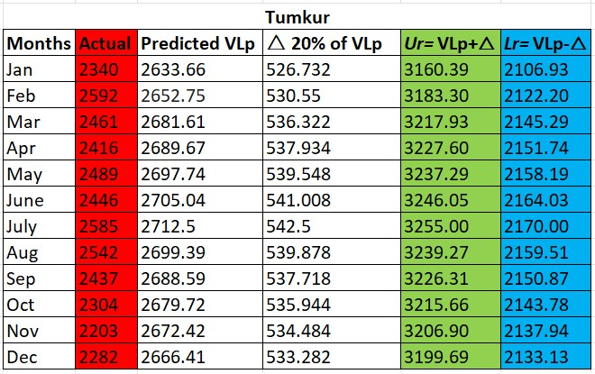
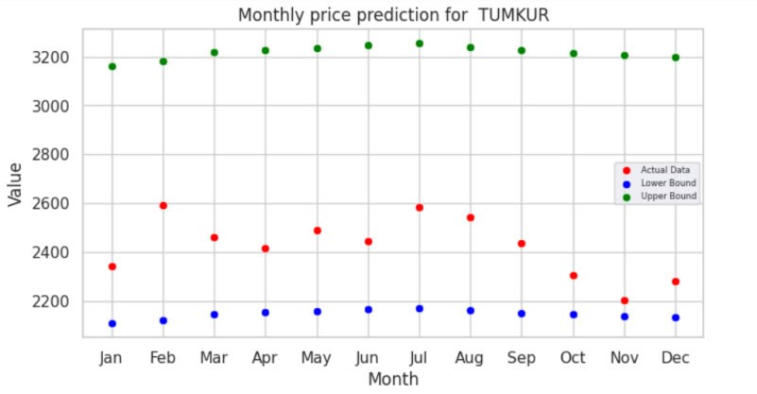
FIGURE 6. Delta calculation for Tumkur.
FIGURE 7. Monthly price prediction for Tumkur.

III. MODEL IMPLEMENTATION
A. DATASET DESCRIPTION AND EXPERIMENTATION SETUP
The real time data is collected from the government website https://agmarknet.gov.in. This dataset includes the historical Ragi arrivals and their price from the year 2010 to 2019 on a monthly basis. Six markets in Karnataka are taken for the study. The experimental investigation is carried out for 10 years, 5 years and 3 years data of Ragi which is collected from Government website. The target year of prediction is taken as 2019. During a 10-year data analysis the data from the year 2010 to 2018 is used as training to predict the price of Ragi. Similarly, the experiment is repeated for 5 years (2015-
2018) and 3 years (2017-2018)
B. TIME SERIES AND NEURAL NETWORK MODELS 1) VECTOR AUTO REGRESSION (VAR)
Vector Auto Regression (VAR) is a time series model used for analyzing the dynamic relationship between multiple stationary time series. It is an extension of the Auto Regressive model (AR) that incorporates multiple variables. VAR is used when you have two or more time series that influence each other. It is suitable for situations where the behavior of one variable depends on its own lagged values as well as the
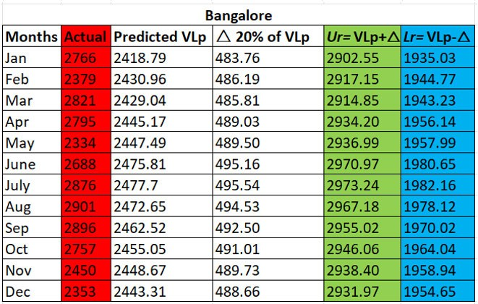
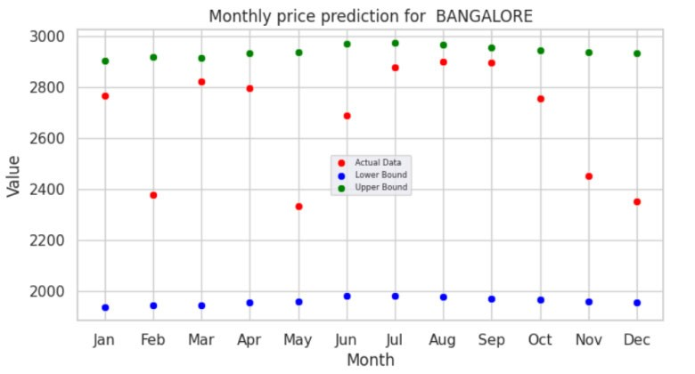
FIGURE 8. Delta calculation for Bangalore.
FIGURE 9. Monthly price prediction for Bangalore.
lagged values of other variables in the system. The order of the VAR model (VAR(n)) is determined by the number of lagged terms considered in the model. If the order is n, it means that each variable in the system depends on its own lags and the lags of the other variables up to the order n. The Equation for the VAR model is given below.
P_{t} =α+ C11,1P_{t}−1 +C12,1A_{t}−1 +_ _ + C₁₁,nP_{t}−n
+ C₁₂,nA_{t}−_{n} + E_{t} (1) LetnbetheorderinVARmodel.α betheintercept.C isthe coefficient. Let A be the Arrival and P be the Price Prediction of Ragi. t is the time period. The Price of Ragi is calculated based on the past price of Ragi and the past arrival (in Tons) to the market. It is calculated for order n. Model summary gives the AIC, BIC, FPE and HQIC scores. Based on the minimum values of AIC and BIC scores n is chosen and VAR model is implemented. For each market, n value is chosen. n is an Auto Regression value in VAR model. This model is applied
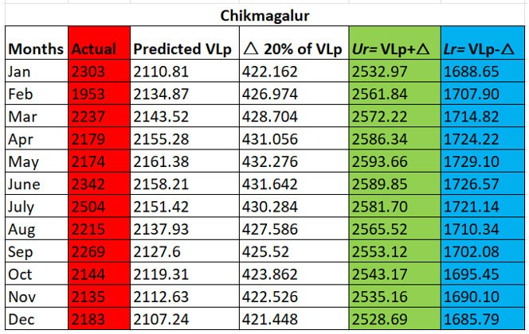
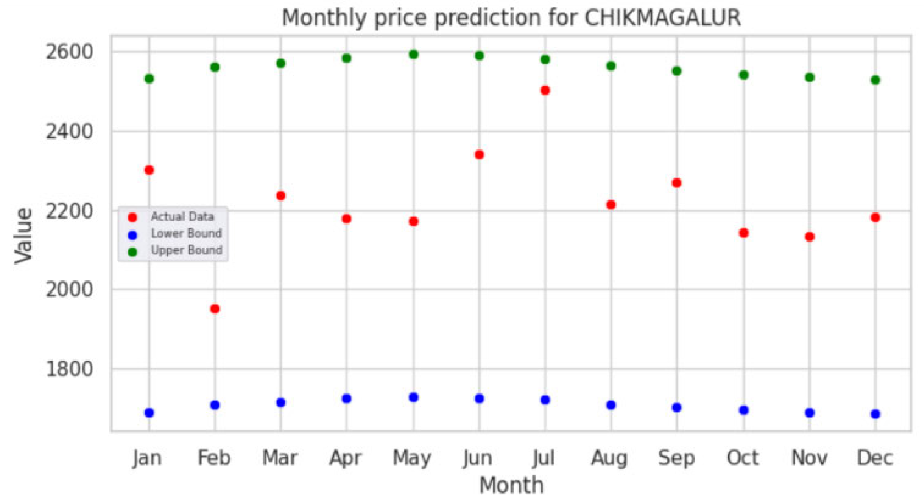
FIGURE 10. Delta calculation for Chikmagalur.
FIGURE 11. Monthly price prediction for Chikmagalur.
for 10 years,5 years and 3 years datasets to predict monthly Ragi Prices of 2019.

2) 1 DIMENSION – CONVOLUTION NEURAL NETWORK(1D-CNN)
In deep learning, a one-dimensional Convolutional Neural Network is a type of neural network that is commonly used for handling one-dimensional time series data. The traditional CNNs were mainly used for image data whereas 1DCNNs are intended to operate on data that has a linear pattern such as audio signals, signals from sensors, or Natural language processing where the input would be a sequence of data points. 1D-CNNs adopts filters to input data that are onedimensional, enabling them to capture relationships and local patterns within the data. These networks contain convolutional layers and then followed by pooling layers and later
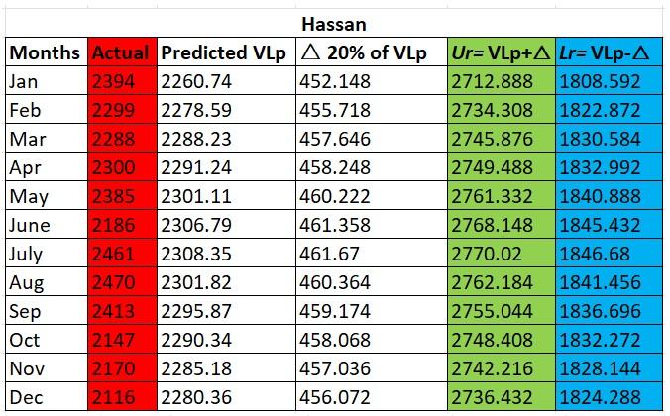
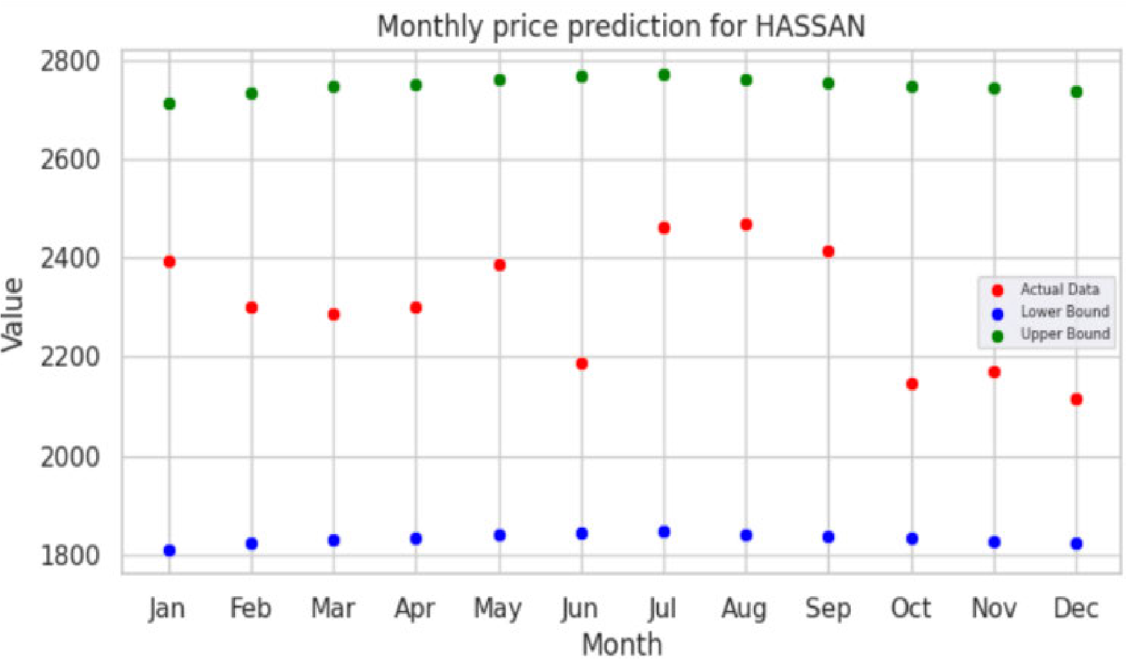
FIGURE 12. Delta calculation for Hassan.
FIGURE 13. Monthly price prediction for Hassan.
connected to fully connected layers. The convolutional layers make use of filters for the input to extract features. The pooling layers minimize the data dimensionality, that aids in the extraction of the relevant features.
Implementing a 1DCNN involves building the architecture by specifying the size and number of filters, pooling strategy and defining the suitable Regularization and activation functions. In our work, we have selected shape of (12,2) for the input layer of the 1DCNN model as shown in Fig (1). The input has a sequence of length 12 with 2 attributes. The model is further configured with 64 filters. Each filter uses kernel size of 2. This is further flattened by the flatten layer. Finally,
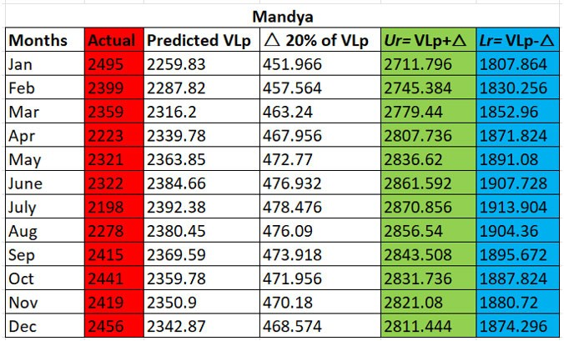
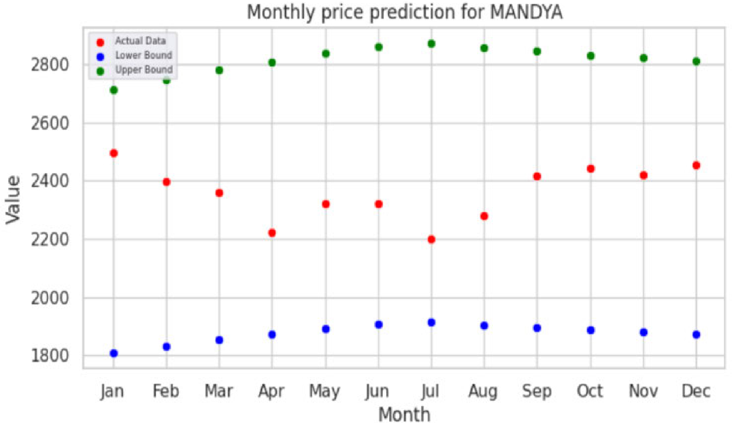
FIGURE 14. Delta calculation for Mandya.
FIGURE 15. Monthly price prediction for Mandya.
it is sent to Dense layer which uses linear activation function to produce the output.

3) LONG SHORT- TERM MEMORY (LSTM)
Long Short-Term Memory (LSTM) algorithm is a type of recurrent neural network that is suitable for making predictions on sequential data. It has overcome the restrictions of RNNs in handling long range dependencies of data. The LSTM adopts a technique to selectively forget or remember information over the time period. The memory cell of LSTM stores information for a long duration. LSTM is built upon input, output and forget gate. Each gate adopts an activation function that controls the data flow, and it also helps in deciding whether the information has to be retained or discarded.
Input Gate is used to Control the movement of new information into the memory cell. Forget Gate is used to discard
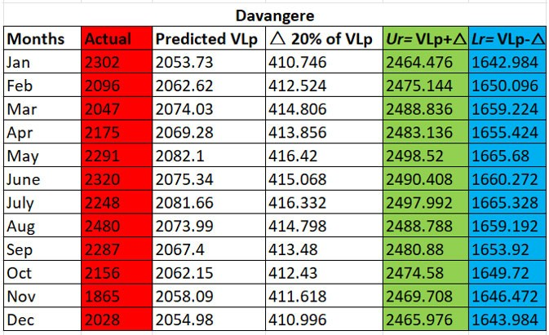
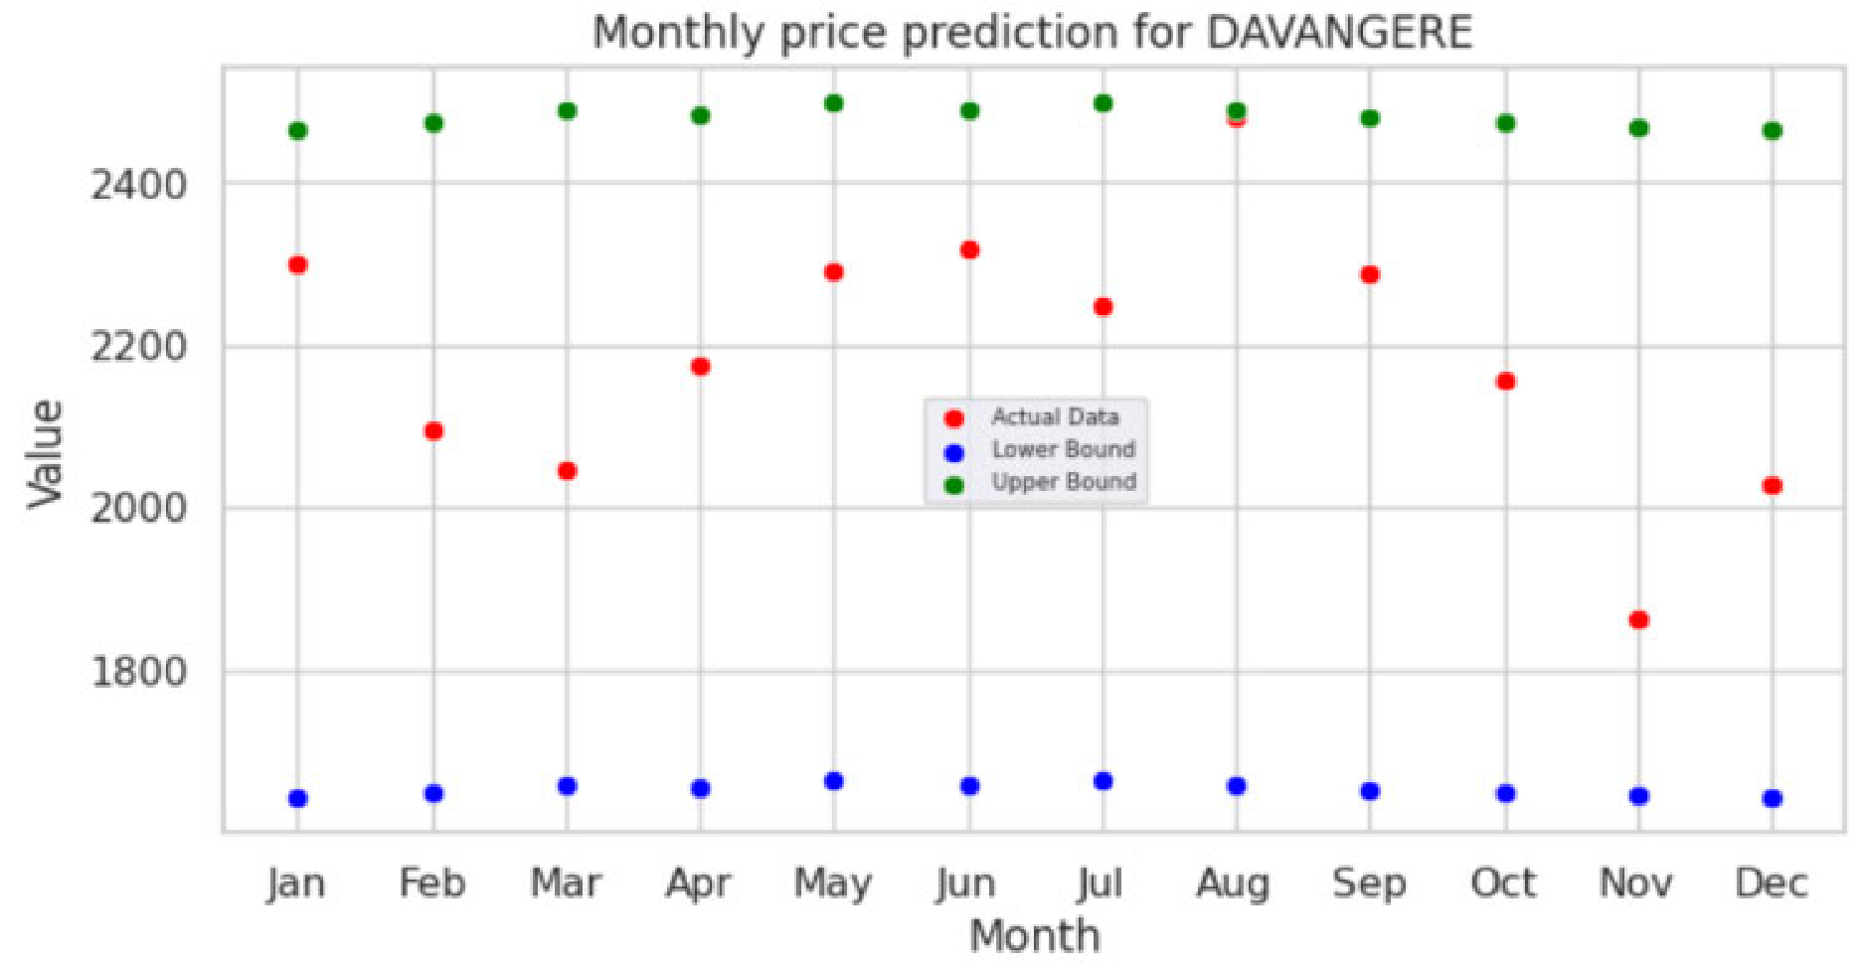
FIGURE 16. Delta calculation for Davangere.
FIGURE 17. Monthly price prediction for Davangere.
irrelevant information from the memory cell. Output Gate transfers the information from the memory cell to the remaining network. In our work, we have chosen 64, 32,32 batches for 10,5 and 3 years respectively as shown in Fig (2). The model uses Arrivals (in Tons) and Previous price of Ragi as features. One dense Layer is used along with Leaky ReLu activation method. Leaky ReLU solves the ‘‘dying ReLU’’ problem as it allows a small gradient when the unit is inactive. The model is made to run for 20 epochs, and monthly Ragi price prediction is made for the year 2019.

4) GATED RECURRENT UNIT (GRU)
GRU is developed as a simplified version of LSTM model. GRU units use gating techniques to regulate the flow of data within the network. This model contains a reset gate and update gate which is used to control the flow of information and help the model to remember or forget information over lengthy sequences. The update gate will decide how much of the previous information has to be passed to the future. The reset gate decides how much of the previous information to forget. This method allows GRUs to be more efficient to be trained on smaller datasets. In our system, GRU model allows input sequences of length 12 with 2 features as shown in Fig (3). Our model has 64 units and uses the tanh function. Dense Layer of 1 unit is added after the GRU layer. Further linear transformation is performed on the GRU’s output. This linear activation function is useful to produce a single output.
- PROPOSED FRAMEWORK
Fig 4 shows the Proposed framework. As per the Literature survey [2], [5], [10] most of the work focused on 10 year data and above [8], [11], [14]. Very few works concentrated less than 10 years [3], [7], [9], [21]. This motivated us to identify minimum number of years lesser than 10 years which would reduce the training time and eventually we took 10,5 and 3 years. The Proposed framework has two phases. Firstly, it identifies the minimum number of years required for the analysisbasedontheperformanceofallthemodels.Secondly for the chosen model a lower and upper range of monthly prices are predicted and validated.
- PROPOSED VAR-STACKED_LSTM MODEL WITH DELTAFOR RANGE CALCULATION 1) FLOWCHART OF VAR-STACKED_LSTM MODEL See Figure 5.

2) ALGORITHM OF VAR-STACKED_LSTM MODEL

VAR model Inputs
A: monthly arrival of Ragi A_{p}: Actual monthly price of Ragi n: the max lag order denoting month
N: number of years Model building
If both time series not stationary then perform differencing till it becomes stationary

Else
1 Adjust the ratio of train and test based on N 2 Select the Max lag n based on minimum AIC scores or BIC scores
3 Fit the train data on VAR model

Outputs
For all the Train data predict, Monthly VAR_Arrival_train of Ragi.
Monthly VAR_Price_train of Ragi.
For all the Test data predict, Monthly VAR_Arrival_test of Ragi. Monthly VAR_Price_test of Ragi.

Stacked_LSTM Inputs
Concatenate the VAR_Arrival_train and
VAR_Arrival_test
Concatenate the VAR_Price_train and
VAR_ Price_test Model building
1.Apply MinMaxScalar on the Arrivals and Price Inputs
2.Divide the data into train and test based on N
3.Apply timeseriesgenerator (win_length_{i}, batch_size_{j}, num_features_{k}) where i, j, k depends on N
4.The Model is built on stacked LSTM and Leaky ReLu activation method and is run for selected number of epochs.
5.Once the training is done the Predictions are done for test data
6.Inverse transform is applied to generate the actual predicted values.

Output
Monthly price prediction of test data MAPE error is used to calculate the mean absolute percentage error on the predicted value Delta computation

Inputs
Let VL _{p} be the Monthly price predicted from
VAR-Stacked_LSTM algorithm

Model building
For every monthly price prediction of the test data
VL_{p}, perform delta computation △
1.Calculate the Upper range U_{r} by adding △_{p} percentage to the predicted value VL_{p}
U_{r} = VL_{p} +△_{p} (2)
2.Calculate the Lower range L_{r} by differencing △_{p} percentage to the predicted value VL_{p}
L_{r} = VL_{p} −△_{p} (3)
3.Validate whether the Actual Price A_{p} is within the range using equation (2) and (3)
L_{r} >= A_{p} <= U_{r} (4)

Output
Lower and Upper Range monthly price of Ragi.

The proposed VAR-Stacked_LSTM model is used to predict monthly price of Ragi for the year 2019.For every monthly prediction delta is used to find the upper and lower range as per equation (2), (3) and (4). The predicted prices for all the regions are within the range as per fig 6 to fig 17.

IV. EXPERIMENTAL ANALYSIS
A. IDENTIFICATION OF MINIMUM NUMBER OF YEARS REQUIRED FOR THE ANALYSIS
In Karnataka popular places of Ragi cultivation are Chikmagalur, Bangalore, Tumkur, Hassan, Mandya, Davangere. Models are tested on 10 years, 5 years and 3 years datasets based on AIC scores. VAR, LSTM, GRU, 1DCNN and VARStacked_LSTM algorithms are applied.
RMSE and MAPE evaluation techniques are used to evaluate the performance of all the algorithms. Initially the RMSE
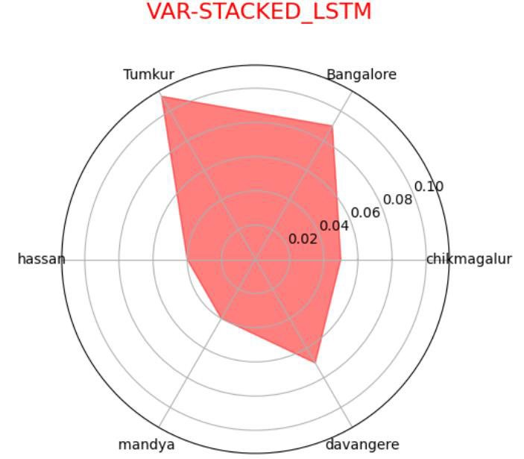
FIGURE 18. Radar plot for VAR-Stacked_LSTM. technique is applied.
r
R = 1 _{X}m A − F 2 (5)
pr _{pr}
m pr=1
R = Root Mean square error m = Number of months in a year Pr₌ month of the year
A_{pr} = Actual Ragi price of the month
F_{pr} = Forecasted Ragi Price of the month
The proposed framework is implemented using Python 3.10.12. Tensorflow 2.12.0 and Keras 2.12.0 are used for LSTM, GRU and 1DCNN models.
The VAR order is chosen based on AIC scores as per Table 1. The same order is used for VAR-Stacked_LSTM. For 10 years datasets the data is taken from 2010 to 2019. The training is done based on monthly data from 2010 to 2018. Monthly Prediction is done for the year 2019.
Among all the algorithms implemented for experimental analysis, the proposed VAR-Stacked_LSTM performed better with RMSE. For 5 years datasets the data is taken from 2015-2019. The training is done based on the data from2015to2018.Testingisdonefortheyear2019.Majority of the cases VAR-Stacked_LSTM proved better than other algorithms. For 3 years 2017 and 2018 data are chosen for training and 2019 for testing. Though CNN model gave good results it is not consistent across all the districts.
The Experimentation is again repeated using BIC scores as shown in Table 2. For 10 and 5 years, VAR-Stacked_LSTM showed better results and for 3 years 1DCNN showed comparatively better results as per Table 2. The comparative study indicates that minimum 5 years of data is required for the experiments.
MAPE evaluation techniques is applied using AIC scores as per Table 3 and BIC scores as per Table 4. When the sample data size is smaller the AIC and BIC values will be closer to
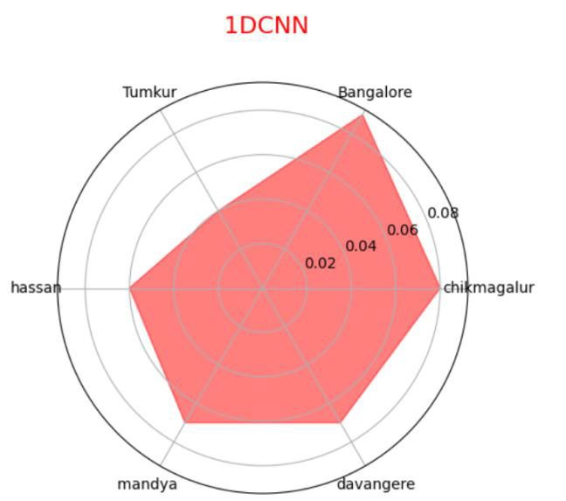
FIGURE 19. Radar plot for 1DCNN.
each other. After comparing the results VAR-Stacked_LSTM with BIC scores of 5 years showed minimum MAPE error
with 1 deviation compared to 10 years of data. For 3-year data a few algorithms are inconsistent as the MAPE error is 0.15 (15%) and above. Also, the VAR order for 5 years data is 1 for all the regions under BIC category. Comparing all the results VAR-Stacked_LSTM algorithm is more consistent with all the regions, and this instigated to work with minimum of 5 years of data.
After comparing two evaluation methods VAR-Stacked_ LSTM performed well in both RMSE and MAPE. Considering 5 years data for VAR-Stacked_LSTM RMSE has very less error 109.83 for Mandya in AIC score. MAPE showed an error of 0.04. Under BIC score category for VARStacked_LSTM RMSE error is 117.26 and 116.64 for Hassan and Mandya respectively. MAPE error is as low as 0.04 for both the regions. Henceforth VAR-Stacked_LSTM is performing well compared to other algorithms
B. MONTHLY WISE PRICE PREDICTION RANGE
Model Evaluation is done across 6 districts and different number of years. VAR-Stacked_LSTM for 5 years dataset is chosen in predicting range for monthly price as it has minimum MAPE value when compared to all other algorithms as shown in Table 3 and Table 4.
Percentage is considered for Delta computation. Initially experimentation was done with delta as 10%. There were maximum number of deviations. Later we experimented with 15% still there were minimum number of deviations. Further we repeated the process with 20%. It gave good results as there were no deviations. After applying 20% to the monthly predicted price the upper and lower range is estimated.
From Fig 6 and Fig 7 it is noted that, in Tumkur district all the monthly prices are closer to the Lower bound. Fig 8
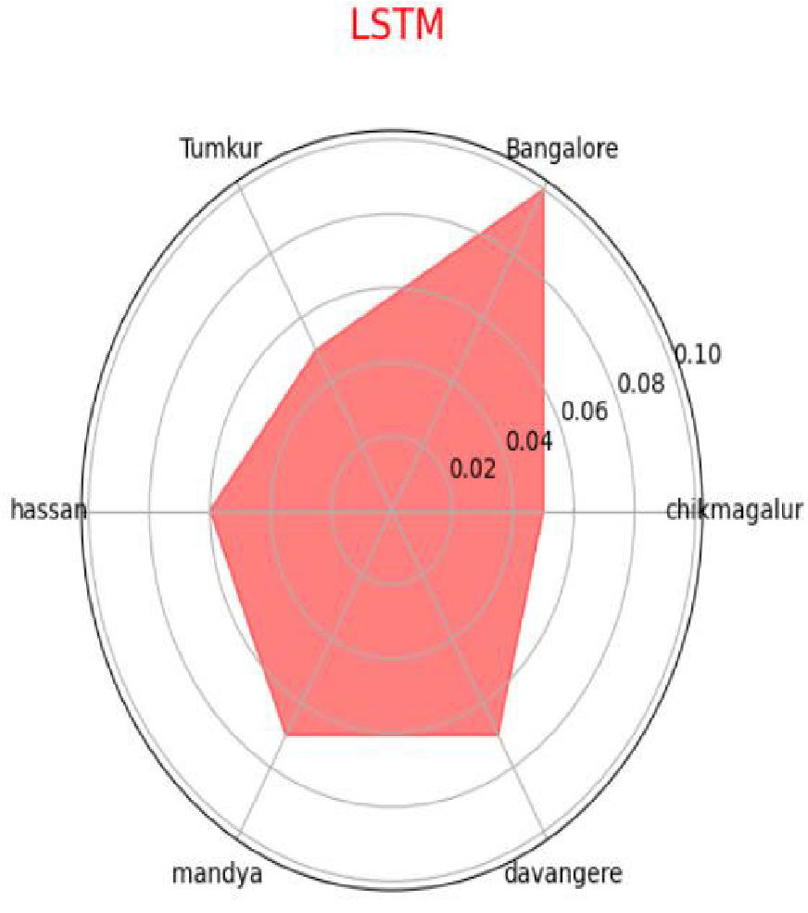
FIGURE 20. Radar plot for LSTM.
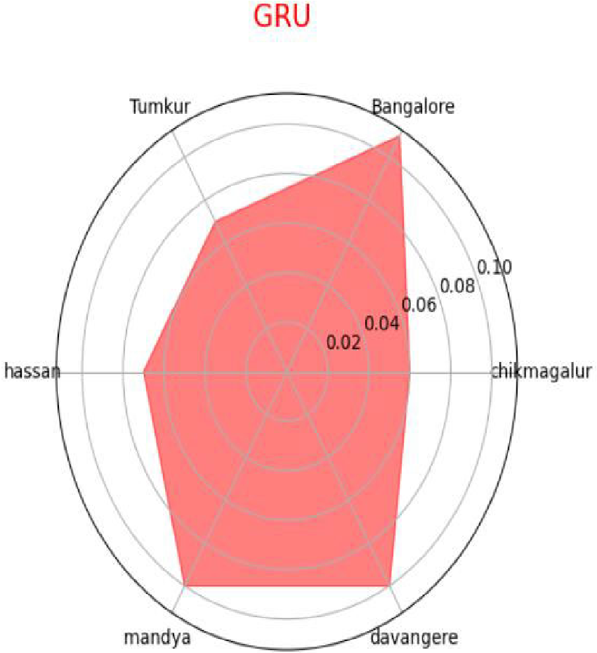
FIGURE 21. Radar plot for GRU.
and Fig 9 shows that Majority of the months in Bangalore are closer to the upper bound. As per Fig 10 and Fig 11 the monthly prices of Chikmagalur are closer to the average of upper and lower bound. The same is reflected for Hassan and Mandya regions as indicated in Fig 12, Fig 13, Fig 14 and Fig 15 respectively. In Davangere, most of the months are closer to the upper bound as shown in Fig 16 and Fig 17. To conclude, all the actual monthly price of Ragi for all 6 districts are within the range.
C. RADAR PLOTS FOR MAPE
MAPE is an Accuracy method applied for forecasting algorithms. This metric is applied to calculate the Mean Absolute
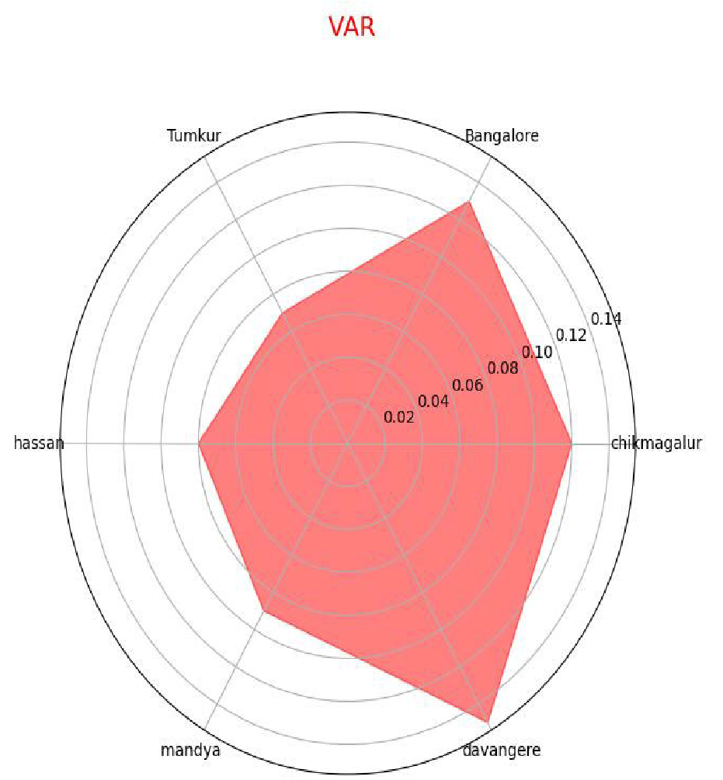
FIGURE 22. Radar plot for VAR. percentage error of Ragi price prediction.
= 1 Xm Apr − Fpr (6) M m Pr=1 A_{pr}
M = Mean Absolute Percentage error m = Number of months in a year Pr = month of the year
A_{pr} = Actual Ragi price of the month
F_{pr} = Forecasted Ragi Price of the month
For Every month from January to December, the difference of Actual price and Forecasted price is divided by Actual price. The cumulative sum is then divided by number of months. Considering BIC scores for 5 years in Fig 18, VARStacked_LSTM has minimum MAPE error 0.04 for Hassan and Mandya. The MAPE errors for Chikmagalur, Bangalore and Davangere were less than 0.10. Only in Tumkur the error is 0.15.
Fig 19 shows that 1DCNN showed minimum error in
Tumkur but all other regions the error is more than VARStacked_LSTM. As per Fig 20 LSTM also has minimum error in Tumkur but the remaining regions have errors comparatively more than VAR-Stacked_LSTM. The GRU algorithm in Fig 21 and VAR in Fig 22 had more errors compared to all the remaining algorithms. The errors are greater than 0.10 in several regions.

V. CONCLUSION AND FUTURE ENHANCEMENT
In this research work, we have developed a unique crop price prediction model. We have collected the data from Government websites. Six regions of Karnataka in India were chosen for the study. An exhaustive experimentation was done to identify the minimum number of years required for the Ragi price analysis. This will help inreducing time forunnecessary analysis in future.
Ragi has excellent storage properties. It can be preserved in gunny bags, earthen grain bins or metallic tins. Ragi can be stored for many years without any damage. This range calculation will benefit the farmers to understand how low and how high the crop price can reach every month. Accordingly, the farmers can plan about the crop sowing, harvesting and selling month.
Experiments are performed on 3,5 and 10 years. Several algorithms such as VAR, LSTM, 1DCNN, GRU and the proposed model VAR-Stacked_LSTM are used to analyze the performance of time series model over the real time data. Historical crop price and Arrivals to the markets were the parameters considered. RMSE and MAPE methods are applied to analyze the errors of the algorithm. VARStacked_LSTM for 5 years comparatively fared well from other algorithms and other years. Further the algorithm is enhanced by computing the monthly price range of Ragi.
Further the same concept can be applied to test other crops and other parameters. The model’s performance can be evaluated by increasing the number of regions.

REFERENCES
- A. Kaur, P. Goyal, R. Rajhans, L. Agarwal, and N. Goyal, ‘‘Fusion of multivariate time series meteorological and static soil data for multistage crop yield prediction using multi-head self attention network,’’ Expert Syst. Appl., vol. 226, Sep. 2023, Art. no. 120098, doi: 10.1016/j.eswa.2023.120098.
- C. Sharma, R. Misra, M. Bhatia, and P. Manani, ‘‘Price prediction model of fruits, vegetables and pulses according to weather,’’ in Proc. 13th Int. Conf. Cloud Comput., Data Sci. Eng. (Confluence), Noida, India, Jan. 2023, pp. 347–351, doi: 10.1109/Confluence56041.2023.10048880.
- C. Z. Yuan, W. W. San, and T. W. Leong, ‘‘Determining optimal lag time selection function with novel machine learning strategies for better agricultural commodity prices forecasting in Malaysia,’’ in Proc. 2nd Int. Conf. Inf. Technol. Comput. Commun., 2020, pp. 37–42, doi: 10.1145/3417473.3417480.
- E. Afzali, A. Adegoke, Z. Jin, W. Qiu, and L. Wang, ‘‘Hybrid VAR-LSTM networksmodelingandforecastingCOVID-19datainCanada-casestudy,’’ Stat. Soc.Canada, Dept. Statist., Univ. Manitoba, Winnipeg, MB, Canada, 2021.
- E. Dave, A. Leonardo, M. Jeanice, and N. Hanafiah, ‘‘Forecasting Indonesia exports using a hybrid model ARIMA-LSTM,’’ Proc. Comput. Sci., vol. 179, pp. 480–487, Jan. 2021.
- I. Abu-Doush, B. Ahmed, M. A. Awadallah, M. A. Al-Betar, and
A. R. Rababaah, ‘‘Enhancing multilayer perceptron neural network using archive-based Harris hawks optimizer to predict gold prices,’’ J. King Saud Univ.-Comput. Inf. Sci., vol. 35, no. 5, May 2023, Art. no. 101557, doi: 10.1016/j.jksuci.2023.101557.
- K. Dhanasekaran, M. Ramprasath, V. Sathiyamoorthi, N. Poornima, and I. A. Jayaraj, ‘‘Meta-learning based adaptive crop price prediction for agriculture application,’’ in Proc. 5th Int. Conf. Electron., Commun. Aerosp. Technol. (ICECA), Coimbatore, India, Dec. 2021, pp. 396–402, doi: 10.1109/ICECA52323.2021.9675891.
- K. Li, N. Shen, Y. Kang, H. Chen, Y. Wang, and S. He, ‘‘Livestock product price forecasting method based on heterogeneous GRU neural network and energy decomposition,’’ IEEE Access, vol. 9, pp. 158322–158330, 2021, doi: 10.1109/ACCESS.2021.3128960.
- L. Cheung, Y. Wang, A. S. M. Lau, and R. M. C. Chan, ‘‘Using a novel clustered 3D-CNN model for improving crop future price prediction,’’ Knowl.-Based Syst., vol. 260, Jan. 2023, Art. no. 110133, doi: 10.1016/j.knosys.2022.110133.
- M. K. Mohanty, P. K. G. Thakurta, and S. Kar, ‘‘Agricultural commodity price prediction model: A machine learning framework,’’ Neural Comput. Appl., vol. 35, no. 20, pp. 15109–15128, Jul. 2023, doi: 10.1007/s00521023-08528-7.
- M. K. Mishra, B. V. S. Sisodia, and V. N. Rai, ‘‘Forecasting technique of price of potato of Uttar Pradesh,’’ J. Pharmacognosy Phytochem., vol. 8, no. 3, pp. 60–62, 2019.
- M. M. Rahman and A. Robson, ‘‘Integrating Landsat-8 and Sentinel-2 time series data for yield prediction of sugarcane crops at the block level,’’ Remote Sens., vol. 12, no. 8, p. 1313, Apr. 2020, doi: 10.3390/rs12081313.
- P. Nevavuori, N. Narra, and T. Lipping, ‘‘Crop yield prediction with deep convolutional neural networks,’’ Comput. Electron. Agricult., vol. 163, Aug. 2019, Art. no. 104859, doi: 10.1016/j.compag.2019.104859.
- R. Vijaya Kumari, P. Venkatesh, G. Ramakrishna, and A. Sreenivas, ‘‘Chilli price forecasting using auto regressive integrated moving average (ARIMA),’’ Int. Res. J. Agricult. Econ. Statist., vol. 10, no. 2, pp. 290–295, Sep. 2019.
- S. Khaki, L. Wang, and S. V. Archontoulis, ‘‘A CNN-RNN framework for crop yield prediction,’’ Frontiers Plant Sci., vol. 10, p. 1750, Jan. 2020, doi: 10.3389/fpls.2019.01750.
- S. A. Prassanna, B. A. Harshanand, B. Srishti, R. Chaitanya,
K. N. Soundari, V. Sriram, M. Kumar, V. Chennamsetti,
G. Venkateshwaran, and P. K. Maurya, ‘‘Crop value forecasting using decision tree regressor and models,’’ Eur. J. Mol. Clin. Med., vol. 7, no. 2, pp. 3702–3722, 2020.
- S. Ouhame and Y. Hadi, ‘‘Multivariate workload prediction using vector autoregressive and stacked LSTM models,’’ in Proc. New Challenges Data Sci., Acts 2nd Conf. Moroccan Classification Soc., New York, NY, USA, 2019, pp. 1–7, doi: 10.1145/3314074.3314084.
- S. Bayona-Oré, R. Cerna, and E. T. Hinojoza, ‘‘Machine learning for price prediction for agricultural products,’’ WSEAS Trans. Bus. Econ., vol. 18, pp. 969–977, Jun. 2021, doi: 10.37394/23207.2021.18.92.
- V. Sneha and V. Bhavana, ‘‘Sugarcane yield and price prediction using forecasting models,’’ in Proc. Int. Conf. Artif. Intell. Knowl. Discovery Concurrent Eng. (ICECONF), Chennai, India, Jan. 2023, pp. 1–6, doi: 10.1109/ICECONF57129.2023.10084094.
- S. Visnu Dharsini and S. Babu, ‘‘Advanced agronomics model with species classification, minimum support price prediction, and profit suggestion using enhanced deep learning strategy,’’ Knowl. Inf. Syst., vol. 65, no. 3, pp. 1243–1285, Mar. 2023, doi: 10.1007/s10115-022-01787-1.
- Y. Weng, X. Wang, J. Hua, H. Wang, M. Kang, and F.-Y. Wang, ‘‘Forecasting horticultural products price using ARIMA model and neural network based on a large-scale data set collected by web crawler,’’ IEEE Trans. Computat. Social Syst., vol. 6, no. 3, pp. 547–553, Jun. 2019, doi: 10.1109/TCSS.2019.2914499.

K. MEENA received the B.E. degree in ECE and the M.E. and Ph.D. degrees in CSE from Manonmaniam Sundaranar University, in 2002, 2009, and 2014, respectively. She had 18 years of teaching experience in various reputed organizations. She is currently a Professor with the Department of Computer Science and Engineering, GITAM School of Technology, GITAM University, Bengaluru, India. Under her guidance, four Ph.D. were awarded and five Ph.D. scholars are pursuing their degree. She
has published papers in more than 100 international journals and conferences. She has five Indian patents and one Australian patent to her credit. Her research interests include biometrics, machine learning for information retrieval, computer vision, agriculture, and medical data analysis.

B. CHAITRA received the B.E. degree in ISE and the M.Tech. degree in software engineering from Visvesvaraya Technological University, in 2004 and 2009, respectively. She was a Resource Person in few faculty development programs. She is currently a Research Scholar with the Department of Computer Science Engineering, GITAM School of Technology, GITAM University, Bengaluru, India. She has published few papers in international journals and conferences.
Her current research interests include machine learning and the IoT.

